Instruction Manual
Hydraulic Drum Dumpers
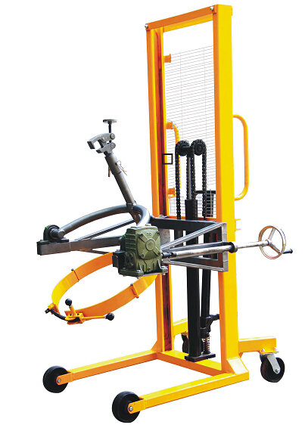

DA45 DA45-1
Note:The Owner/Operator must read carefully and understand all the information presented here before operation
DA45 series Drum dumper Figure

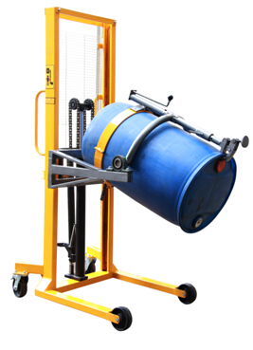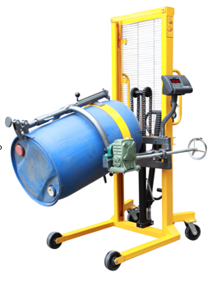
DA45 DA45-1
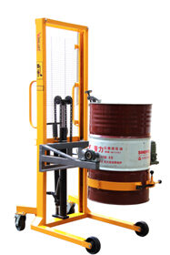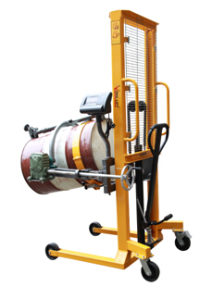

DA45 DA45-1

Preface

l. In order to make the users quickly understand the structure and performance features of this product, so as to carry out regular maintenance as well as correct regulation of vehicle, our factory hereby compile this operation instruction sheet as well as spare parts table for users' reference.
2. Read the instruction sheet and parts table carefully before using and make clear the structural performance, Maintenance as well as attentions.
3. The personnel without license cannot operate the drum dumper. Only those qualified personnel with professional training as well as approved by relevant departments and familiar with the structural performance can independently operate the vehicle.
4. The work site of drum dumper shall be flat, solid place with enough loading capacity.
5. Our company will not hold any responsibility for the modification of drum rotator by users without the prior approval of our company.

Table of Contents
1、Brief introduction

2、Main technical performance and parameter

3、Technical Data

4、Safety operation

5、Maintenance

1、Brief Introduction

Safe drum dumping requires well-designed, ergonomic drum handling equipment to reduce risks of injury or property damage. hydraulic Drum Karriers, drum dumpers DA45 combine incredible strength with simple drum handling by one person. It can help you lift, move and pour plastic, fiber and steel drums, and also can provide controlled dispensing of your drums.
With the feature of simple design and easy operation, this all steel construction Hydraulic Drum Dumper is what you need to dump steel & plastic drums that weigh up to 450kg.

2.Main Technical Performance and Parameter
2.1
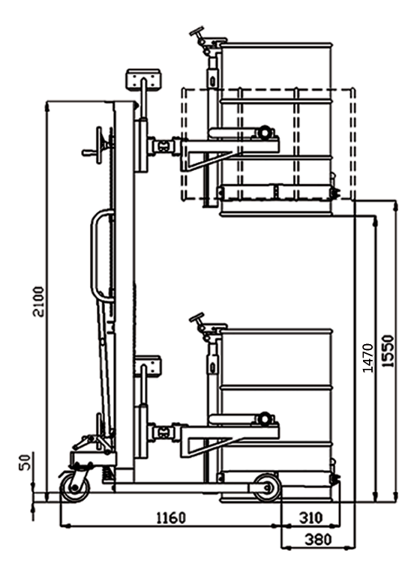

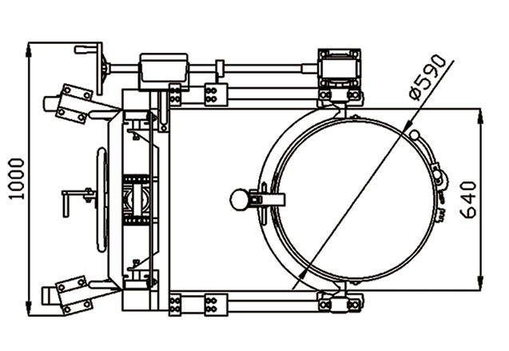

2.2. Feature Of
Hydraulic Drum Dumpers
1. Floor lock;
2. Load capacity 450kg;
3. Base leg span 640mm;
4. Combined Eagle-grip structure and Anchorear structure together;
3. Suitable for handling steel and plastic drums;
4. Can be operated by one people
6. Manually rotate drums 180 degree;
7. Can keep drums at any angle;
8. The solid steel construction provides stability during transit;
9. Lowers drums to the floor;
10. All steel construction;
11. Drum Karriers provide controlled dispensing of your drum;
12. Suitable for 55 gallon steel drums & 210L rimmed plastic drums;
13. Widely used for chemical plants and food plants for transferring, loading & unloading, charging and compounding materials of fluids, such as dyes, paintings, adhesives, petrol, edible oils, etc
14. Special rolling technology manufacturing "C" type door frame, strong security

3、Technical Data

Model |  | Hydraulic Drum Dumpers, Drum Handler DA45
Load capacity | kg | 450
Net weight | Kg | 176
Lifting height | mm | 1500
Pouring height | mm | 1580
Caster dimension | mm | Ø150*50
Inner/Outer width of front support legs | mm | 650/810
Max. Grade ability (Fully-loaded/no-load) | % | 3/5
Overall size | mm | 1400*1000*2100

4、Safety operation
Operation of electric drum dumper
- Open the anchor ear, adjust the lock ring-pull, making the anchor ear hold tightly the drum which need be transported. The plastic drum should use limiting stopper.
- It can customize pedal and manually type , lifting the drum to the specified height. It can manually rotate 360 degree.

5. Maintenance

Weekly inspection
1. Check and screw up bolts and nuts;
2. Add butter to the UPC bearing every week regularly;
3. Change oil every a half year;

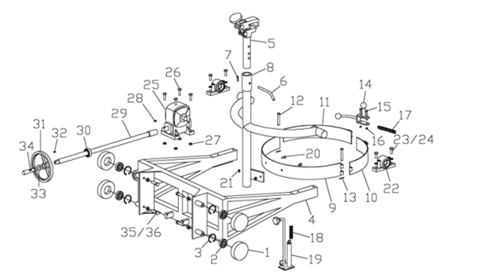

NO. | Name | Unit | Qty | NO. | Name | Unit | Qty
A1 | Scroll wheel | pcs | 4 | A19 | Drum clasp | pcs | 1
A2 | 205 Bearing | pcs | 4 | A20 | M8X20 sunk screw | pcs | 2
A3 | φ52 Hole Stop Collar | pcs | 4 | A21 | M8 nut | pcs | 2
A4 | Inner Tower | pcs | 1 | A22 | Bearing pedestal | pcs | 2
A5 | Clamp | pcs | 1 | A23 | M10X30 bolt | pcs | 4
A6 | Fixed pin | pcs | 1 | A24 | φ10 Flat Gasket | pcs | 4
A7 | R type pin | pcs | 1 | A25 | Speed Reducer | pcs | 1
A8 | Clamp frame | pcs | 1 | A26 | M10X40 bolt | pcs | 4
A9 | Hoop 1 | pcs | 1 | A27 | M10 Nut | pcs | 4
A10 | Hoop 2 | pcs | 1 | A28 | Pin 1 | pcs | 1
A11 | Hoop 3 | pcs | 1 | A29 | Connecting rod | pcs | 1
A12 | Hoop Roller | pcs | 2 | A30 | 205 Bearing | pcs | 1
A13 | Hoop Pin | pcs | 2 | A31 | Hand wheel | pcs | 1
A14 | Fastening Pieces | pcs | 1 | A32 | Pin 2 | pcs | 1
A15 | M8X15 bolt | pcs | 2 | A33 | Gasket | pcs | 1
A16 | M8 Nut | pcs | 6 | A34 | M5X10 bolt | pcs | 1
A17 | Fastening chain | pcs | 1 | A35 | M12X80 bolt | pcs | 4
A18 | Spring | pcs | 1 | A36 | M12 Nut | pcs | 4

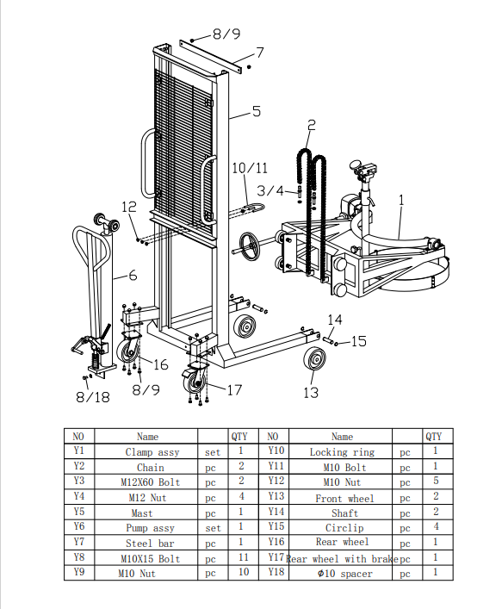

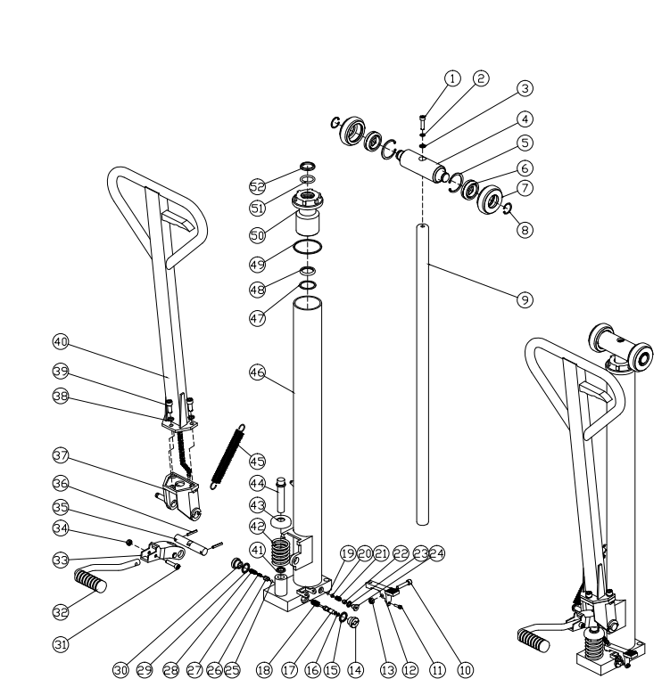

Item NO. | Name | Unit | Qty | Item NO. | Name | Unit | Qty
1 | Hexagon socket head cap bolts M10*25 | pcs | 1 | 2 | Spring pad D10 | pcs | 1
3 | Flat pad D10 | pcs | 1 | 4 | Sprocket shaft | pcs | 1
5 | Hole with the ring | pcs | 2 | 6 | Bearing | pcs | 2
7 | Sprocket | pcs | 2 | 8 | Shaft with the ring | pcs | 2
9 | Piston rod | pcs | 1 | 10 | Hexagon socket head cap bolts M8*40 | pcs | 1
11 | Screw pin M6 | pcs | 1 | 12 | Relieve the pedal | pcs | 1
13 | Self-locking nuts | pcs | 1 | 14 | Pressure relief screws M20 | pcs | 1
15 | Combination pad D20 | pcs | 1 | 16 | O-ring φ10*1.9 | pcs | 2
17 | Pressure relief valve spool | pcs | 1 | 18 | Pressure relief spring | pcs | 1
19 | Steel ball φ5 | pcs | 1 | 20 | Ball seat | pcs | 1
21 | Pressure spring | pcs | 1 | 22 | Pressure screw | pcs | 1
23 | Combination pad D10 | pcs | 1 | 24 | Pressure screw M10*1 | pcs | 1
25 | steel ball φ6.35 | pcs | 1 | 26 | Body | pcs | 1
27 | Spool | pcs | 1 | 28 | Pagoda spring | pcs | 1
29 | Combination pad D20 | pcs | 1 | 30 | Screw M20*1.5 | pcs | 1
31 | Hexagon socket head cap bolts M8*35 | pcs | 1 | 32 | Lift the pedal | pcs | 1
33 | Foot connection block | pcs | 1 | 34 | Self-locking nuts M8 | pcs | 1
35 | Handrail pin | pcs | 1 | 36 | Pin | pcs | 2
37 | Handrail base | pcs | 1 | 38 | Spring pad D10 | pcs | 3
39 | Hexagon socket head cap bolts M10*25 | pcs | 3 | 40 | Handrail | pcs | 1
41 | Dust ring φ18 | pcs | 1 | 42 | Pressure spring | pcs | 1
43 | Pressure spring cover | pcs | 1 | 44 | Small piston rod | pcs | 1
45 | Tension spring | pcs | 1 | 46 | Cylinder | pcs | 1
47 | Copper gasket φ44*φ37*1.5 | pcs | 1 | 48 | Sealing ring φ31.5 | pcs | 1
49 | Gasket φ69*φ62*2 | pcs | 1 | 50 | Guide sleeve | pcs | 1
51 | O-ring φ31.5*3.65 | pcs | 1 | 52 | Dust ring φ31.5 | pcs | 1

